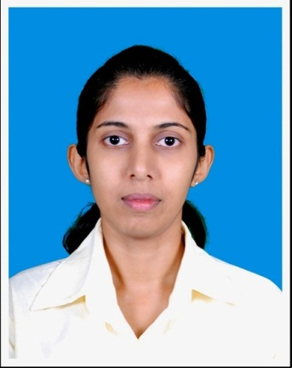**Curriculum Vitae**

**NISHANI DEEPASHIKA DASSANAYAKE**

No.35,M.S.O,Riverside, Mawathura, Gampola

E-mail: [nishanidassanayake@gmail.com](mailto:nishanidassanayake@gmail.com)

Telephone No: +94779850992(Mobile)

# Statement of interest

I am a fresh graduate with honor Bachelor in Science Special in Tea Technology and Value Addition (English medium) from Uva Wellassa University. I possess excellent communication skills and I have the ability and experience to relate to a wide range of people with my previous experience and knowledge.

# EDUCATION QUALIFICATION

* B.Sc. (Sp) Tea Technology and Value Addition Degree Program (English medium), Faculty of Animal Science and Export Agriculture in Uva Wellassa University of Sri Lanka.

**Core Areas:**

* Strategies in Human resources management
* Macro and micro economics
* Marketing
* Agribusiness management
* Crop Botany
* Tea chemistry
* Financial Accounting, Business and Entrepreneurial skills
* Quality Assurance and certification
* Statistical science
* Tea process Engineering
* Biotechnology
* Plantation management (nursery, field operations, pest and disease management, soil science, microbiology)
* Value addition to Tea crop of Sri Lanka
* G.C.E. Advanced Level Examination – 2010

|  |  |
| --- | --- |
| **Subject** | **Result** |
| Physics | B |
| Chemistry | B |
| Biology | S |
| General English | B |

* G.C.E Ordinary level (2005) at Girls High School, Kandy

|  |  |
| --- | --- |
| **Subject** | **Results** |
| Science and Technology | A |
| Mathematics | A |
| English Language | A |
| Sinhala Language | A |
| Buddhism | A |
| Health and Physical Education | A |
| Horticulture | A |
| Drama And theatre | B |

* Successfully completed The basic Extention Course in English at University of Peradeniya
* Successfully completed Field Trainning Program in Balangoda Plantations PLC

# EXTRA CURRICULAR ACTIVITIES& achievements

**Career Level**

* Radio Presenter at Kothmale Community Radio
* Conduct Kids computer courses and mathematics, science classes at Kothmale nenasala combined with ICTA
* Successfully completed one month Training at the Amazon Trading Pvt Ltd

**University Level**

* won as “Best Announcer” in the university Art week 2012
* Member of university media team
* Contribute many events within the university as well as out side the university as an announcer such as new year festivals, art week, glamoro event,’ la season de tourisome exhibition, wesak festival etc.

**School level**

* Member of Kandy Girls High School Youth Explorer Unit
* Member of a Kandy Girls High School Buddhist society
* Member of Science society in Kandy Girls High School

# skills and competency

* Communication skills in both English and Sinhala Language
* Familiar with Adobe Audition 1.5 software
* Familiar with Microsoft office package
* Working ability with teams

# PERSONAL PROFILE

Full Name : Kangarammulle Gedara Nishani Deepashika Dassanayake

Name With Initials : K.G.N.D. Dassanayake

Date of Birth : 20th of December 1989

Age : 25 years

NIC Number : 898553540V

Sex : Female

Civil Status : Single

School Attended : Girls’ High School, Kandy

# NON RELATED REFEREES

|  |  |
| --- | --- |
| Mr. A.N.R. Weerawansha | Ms Achala Alakolanga |
| lecturer,  Faculty of Animal Science and Export Agriculture,  Uva wellassa University,  Passara road, Badulla  0772296127 | Lecturer,  Faculty of Animal Science and Export Agriculture,  Uva wellassa University,  Passara road, Badulla  0772975582  [wimukthikaag@gmail.com](mailto:wimukthikaag@gmail.com) |

I do here by certify that the particulars furnished above are true and correct to the best of my knowledge.

...............................

K.G.N.D.Dassanayake